AI Practical Exam
------------------------------Practical 1-----------------------------
1.1 Tower of Hanoi
Algorithm:
1. Move n-1 disks from the source rod to the auxiliary rod, using the target rod as temporary.
2. Move the nth (largest) disk directly from source to target.
3. Move the n-1 disks from the auxiliary rod to the target rod, using the source rod as temporary.
4. Base case: when only 1 disk remains, move it directly from source to target.
Explanation:
Tower of Hanoi is a classic recursion problem in which you move a stack of disks from one rod to another, moving one disk at a time so that a larger disk is never placed on a smaller one.
Code:
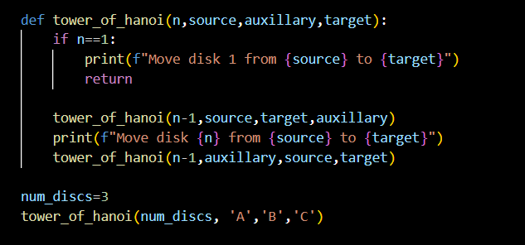
Output:
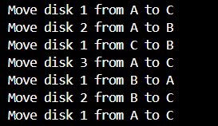

1.2 N-Queens Problem
Algorithm:
1. Represent the board as an array where board[row] = column of the queen placed in that row.
2. For each row, try placing a queen in every column.
3. A position is safe if no previously placed queen shares the same column or same diagonal with it (is_safe).
4. Place the queen, then recursively move to the next row (solve_n_queens).
5. If placing in a column does not lead to a solution, undo the placement (backtrack) and try the next column.
6. When all n rows are filled, the solution board is printed.
Explanation:
The N-Queens problem places N queens on an N x N chessboard so that no two queens attack each other. Backtracking tries to place one queen per row and undoes any placement that leads to a dead end.
Code:
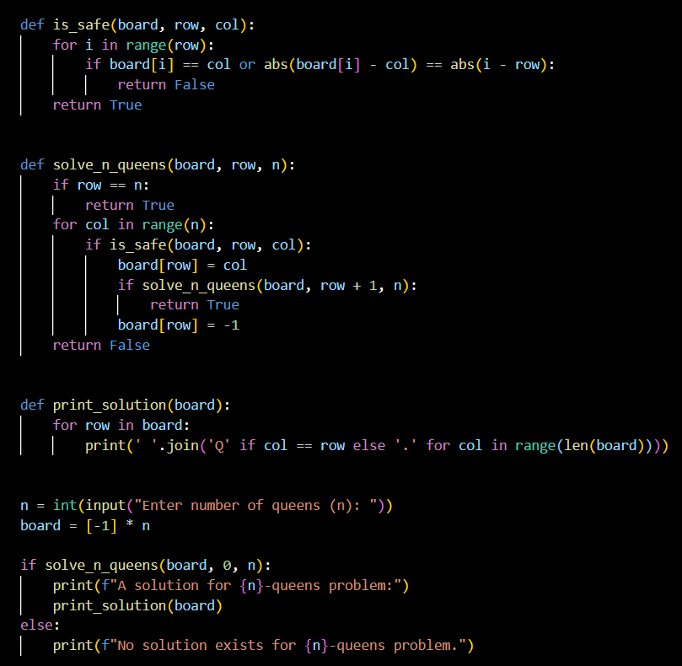
Output:
Enter number of queens (n): A solution for 4-queens problem:
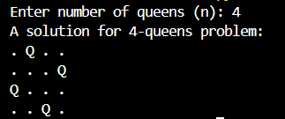

------------------------------Practical 2------------------------------
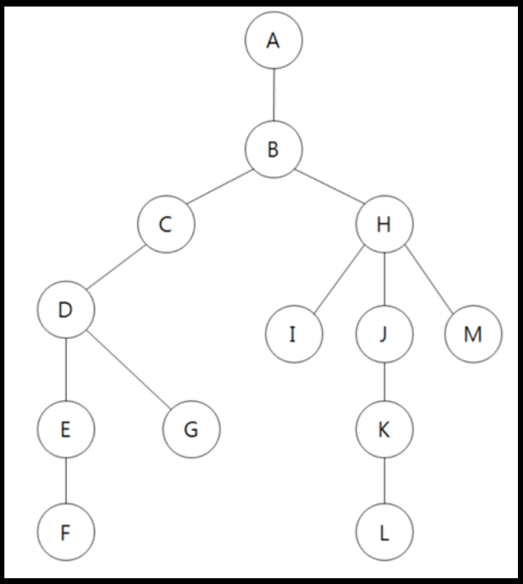
Algorithm:
BFS Algorithm:
1. Mark the starting node as visited and insert it into a queue.
2. While the queue is not empty, remove the front node and add it to the traversal result.
3. For each unvisited neighbour of that node, mark it visited and push it into the queue.
DFS Algorithm:
1. Mark the starting node as visited and push it onto a stack.
2. While the stack is not empty, pop the top node and add it to the traversal result.
3. For each unvisited neighbour of that node, mark it visited and push it onto the stack.
Explanation:
BFS (Breadth-First Search) explores a graph level by level using a queue, visiting all neighbours of a node before moving deeper. DFS (Depth-First Search) explores as far as possible along each branch using a stack, then backtracks.
Code:
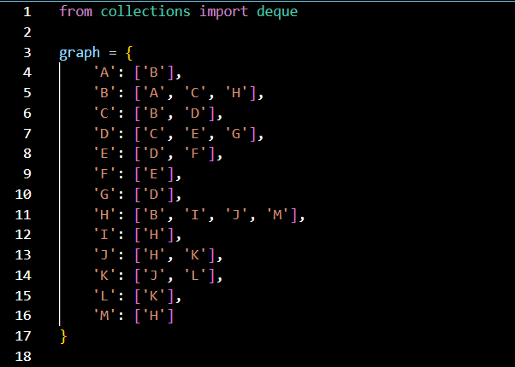
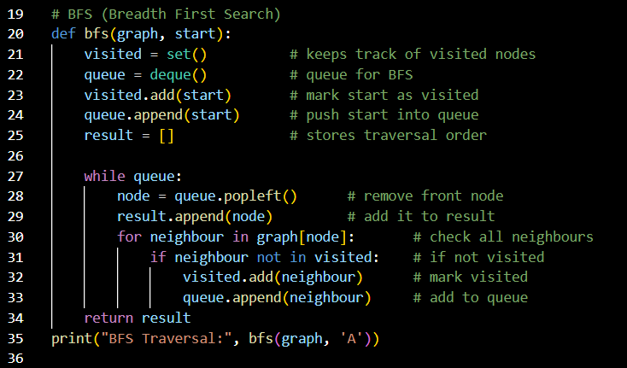
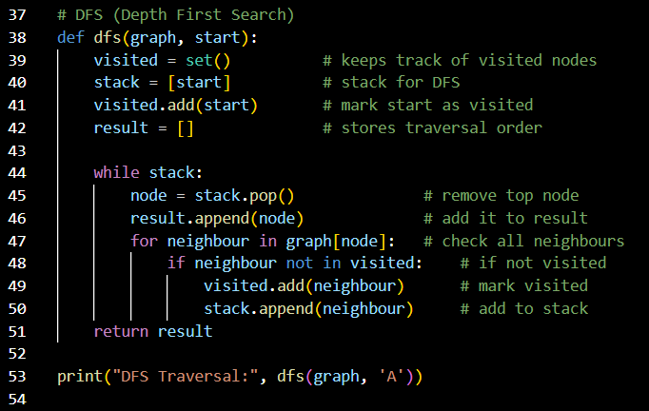
Output:
------------------------------Practical 3------------------------------
Algorithm:
1. Initialise the open list (priority queue) with the start node, sorted by f = g + h.
2. Pop the node with the smallest f value from the open list.
3. If it is the goal node, reconstruct the path using the parent pointers and return it.
4. For each neighbour, compute new_g = current g + edge cost.
5. If new_g is better than the recorded g_score, update g_score, set the parent, compute f = new_g + heuristic, and push it into the open list.
Explanation:
A* is a best-first search that finds the shortest path by expanding the node with the smallest
f = g + h, where g is the actual cost from the start and h is an estimated (heuristic) cost to the goal.
Code:
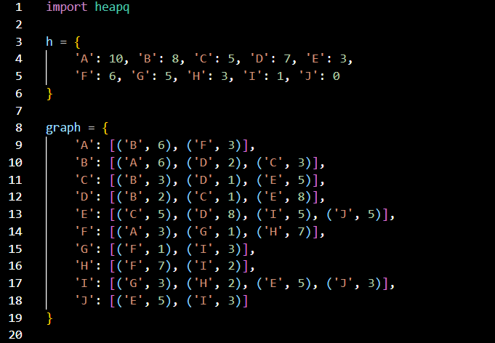
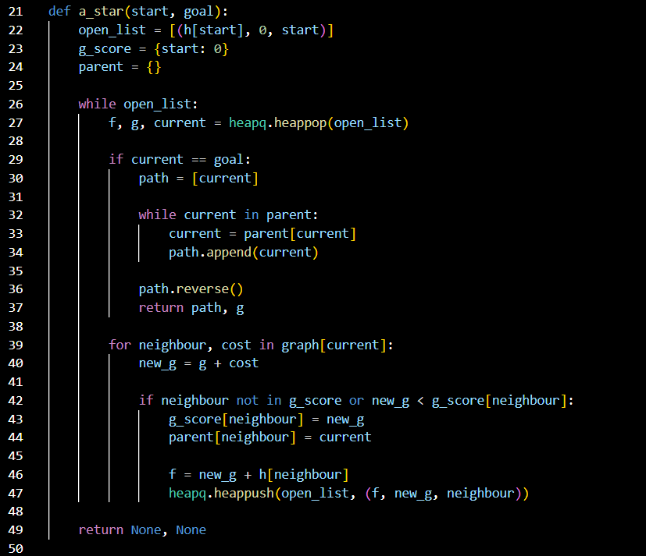
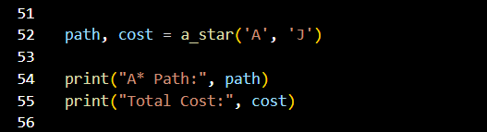
Output:
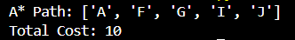
------------------------------Practical 4------------------------------

------------------------------Practical 5------------------------------
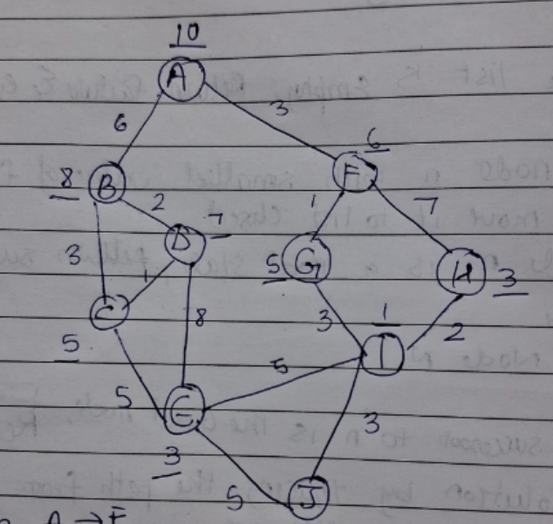
Algorithm:
1. Traverse the game tree in a depth-first manner (Minimax).
2. Maintain alpha (best value for MAX, initially -infinity) and beta (best value for MIN, initially +infinity).
3. At a MAX node, pick the maximum of the child values and update alpha.
4. At a MIN node, pick the minimum of the child values and update beta.
5. Prune: whenever beta <= alpha, stop exploring the remaining children of that node.
6. Return the best value obtained from the root.
Explanation:
Alpha-beta pruning optimises the Minimax algorithm by cutting off branches that cannot influence the final decision. It keeps alpha and beta bounds and gives the same result while evaluating fewer nodes.
Code:
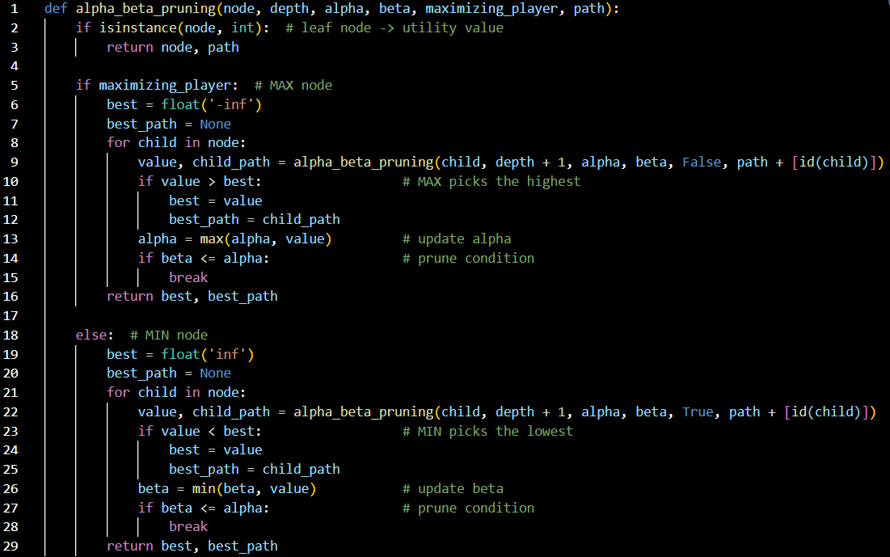
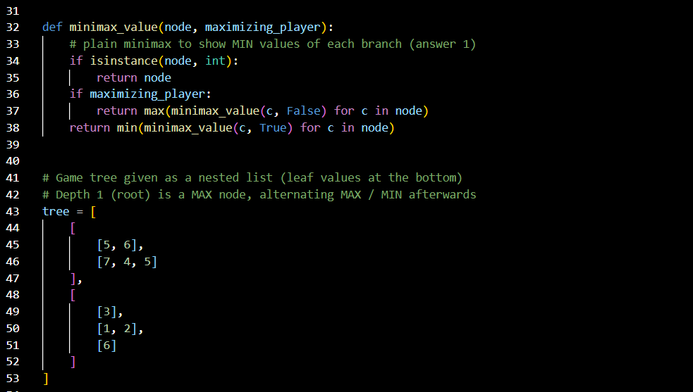
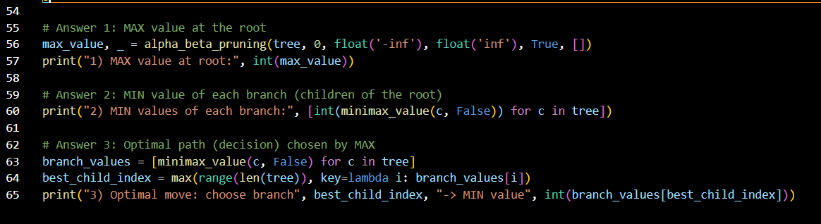
Output:
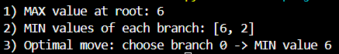
------------------------------Practical 6------------------------------
------------------------------Practical 7------------------------------
------------------------------Practical 8------------------------------
------------------------------Practical 9------------------------------

